федеральное государственное автономное образовательное учреждение высшего образования
«НАЦИОНАЛЬНЫЙ ИССЛЕДОВАТЕЛЬСКИЙ УНИВЕРСИТЕТ ИТМО»

ОТЧЕТ
по лабораторной работе №7
«Создание сети IPv6»
по дисциплине «Администрирование систем и сетей»
Вариант на оценку 5

Авторы: Кулаков Н. В.
Факультет: ПИиКТ
Группа: P34312
Преподаватель: Афанасьев Д.Б.


Санкт-Петербург 2023
Оглавление
1. Лабораторная работа 3
1.1. Задачи 3
1.2. Топология 3
1.3. Настраивание и диагностические команды 3
1.4. Конфигурации 8
2. Дополнительное задание. DHCP-pd и наличие записей о подсетях клиентов на ISP router 11
2.1. Топология 11
2.2. Конфигурации 11
2.3. Настраивание и диагностические команды 16

Лабораторная работа

Задачи
- Настройка статических адресов IPv6.
- Настройка сервера DHCPv6.
- Настройка назначения адресов IPv6 без отслеживания состояния.
- Вывод на экран адресов IPv6

Топология
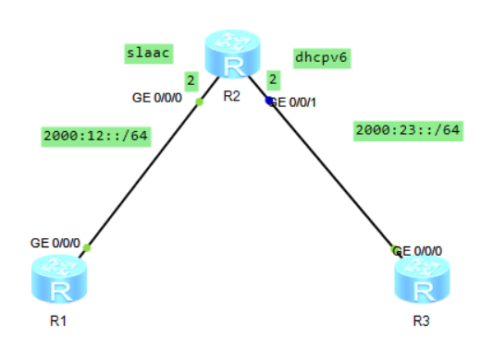

Настраивание и диагностические команды
Шаг 1,2.
Настроить имена на устройствах, включить ipv6.
Шаг 3.
Настроить локальные адреса канала на устройствах. Генерируются автоматически.
[R1-GigabitEthernet0/0/0]ipv6 addr auto link-local

[R1]dis ipv6 interface
GigabitEthernet0/0/0 current state : UP
IPv6 protocol current state : UP
IPv6 is enabled, link-local address is FE80::2E0:FCFF:FE4F:3BBD
No global unicast address configured
Joined group address(es):
FF02::1:FF4F:3BBD
FF02::2
FF02::1
MTU is 1500 bytes
ND DAD is enabled, number of DAD attempts: 1
ND reachable time is 30000 milliseconds
ND retransmit interval is 1000 milliseconds
Hosts use stateless autoconfig for addresses

[R2-GigabitEthernet0/0/1]dis ipv6 interface
GigabitEthernet0/0/0 current state : UP
IPv6 protocol current state : UP
IPv6 is enabled, link-local address is FE80::2E0:FCFF:FE18:3CF6
No global unicast address configured
Joined group address(es):
FF02::1:FF18:3CF6
FF02::2
FF02::1
MTU is 1500 bytes
ND DAD is enabled, number of DAD attempts: 1
ND reachable time is 30000 milliseconds
ND retransmit interval is 1000 milliseconds
Hosts use stateless autoconfig for addresses

GigabitEthernet0/0/1 current state : UP
IPv6 protocol current state : UP
IPv6 is enabled, link-local address is FE80::2E0:FCFF:FE18:3CF7
No global unicast address configured
Joined group address(es):
FF02::1:FF18:3CF7
FF02::2
FF02::1
MTU is 1500 bytes
ND DAD is enabled, number of DAD attempts: 1
ND reachable time is 30000 milliseconds
ND retransmit interval is 1000 milliseconds
Hosts use stateless autoconfig for addresses

[R3-GigabitEthernet0/0/0]dis ipv6 interface
GigabitEthernet0/0/0 current state : UP
IPv6 protocol current state : UP
IPv6 is enabled, link-local address is FE80::2E0:FCFF:FE10:8A6
No global unicast address configured
Joined group address(es):
FF02::1:FF10:8A6
FF02::2
FF02::1
MTU is 1500 bytes
ND DAD is enabled, number of DAD attempts: 1
ND reachable time is 30000 milliseconds
ND retransmit interval is 1000 milliseconds
Hosts use stateless autoconfig for addresses

[R1]ping ipv6 FE80::2E0:FCFF:FE18:3CF6 -i GigabitEthernet 0/0/0
PING FE80::2E0:FCFF:FE18:3CF6 : 56 data bytes, press CTRL_C to break
Reply from FE80::2E0:FCFF:FE18:3CF6
bytes=56 Sequence=1 hop limit=64 time = 450 ms
Reply from FE80::2E0:FCFF:FE18:3CF6
bytes=56 Sequence=2 hop limit=64 time = 30 ms
Reply from FE80::2E0:FCFF:FE18:3CF6
bytes=56 Sequence=3 hop limit=64 time = 20 ms
Reply from FE80::2E0:FCFF:FE18:3CF6
bytes=56 Sequence=4 hop limit=64 time = 20 ms
Reply from FE80::2E0:FCFF:FE18:3CF6
bytes=56 Sequence=5 hop limit=64 time = 30 ms

--- FE80::2E0:FCFF:FE18:3CF6 ping statistics ---
5 packet(s) transmitted
5 packet(s) received
0.00% packet loss
round-trip min/avg/max = 20/110/450 ms

Шаг 4.
Настроить статические IPv6 адреса на R2:
[R2-GigabitEthernet0/0/0]ipv6 address 2000:0012::2 64
[R2-GigabitEthernet0/0/1]ipv6 address 2000:0023::2 64
Шаг 5.
Настроить функцию сервера DHCPv6 на R2 и настроить R3 для получения IPv6-адресов через DHCPv6.
interface GigabitEthernet0/0/1
ipv6 enable
ipv6 address 2000:23::2/64
ipv6 address auto link-local
undo ipv6 nd ra halt
ipv6 nd autoconfig managed-address-flag
dhcpv6 server pool1
#
return

[R3-GigabitEthernet0/0/0]dis this
[V200R003C00]
#
interface GigabitEthernet0/0/0
ipv6 enable
ipv6 address auto link-local
ipv6 address auto global default
ipv6 address auto dhcp
#
return

[R3-GigabitEthernet0/0/0]dis ipv6 ro
Routing Table : Public
Destinations : 4 Routes : 4

Destination : :: PrefixLength : 0
NextHop : FE80::2E0:FCFF:FE18:3CF7 Preference : 64
Cost : 0 Protocol : Unr
RelayNextHop : :: TunnelID : 0x0
Interface : GigabitEthernet0/0/0 Flags : D

Destination : ::1 PrefixLength : 128
NextHop : ::1 Preference : 0
Cost : 0 Protocol : Direct
RelayNextHop : :: TunnelID : 0x0
Interface : InLoopBack0 Flags : D

Destination : 2000:23::1 PrefixLength : 128
NextHop : ::1 Preference : 0
Cost : 0 Protocol : Direct
RelayNextHop : :: TunnelID : 0x0
Interface : GigabitEthernet0/0/0 Flags : D

Destination : FE80:: PrefixLength : 10
NextHop : :: Preference : 0
Cost : 0 Protocol : Direct
RelayNextHop : :: TunnelID : 0x0
Interface : NULL0 Flags : D

Шаг 6.
Настроить R1 для получения IPv6-адреса в режиме без отслеживания состояния.
[R2-GigabitEthernet0/0/0]undo ipv6 nd ra halt

[R1-GigabitEthernet0/0/0]ipv6 address auto global
[R1-GigabitEthernet0/0/0]display ipv6 interface brief
*down: administratively down
(l): loopback
(s): spoofing
Interface Physical Protocol
GigabitEthernet0/0/0 up up
[IPv6 Address] 2000:12::2E0:FCFF:FE4F:3BBD

Шаг 7.
Настроить статический маршрут IPv6:
[R1-GigabitEthernet0/0/0]ipv6 route-static 2000:23:: 64 2000:12::2

[R1]ping ipv6 2000:23::1
PING 2000:23::1 : 56 data bytes, press CTRL_C to break
Request time out
Reply from 2000:23::1
bytes=56 Sequence=2 hop limit=63 time = 90 ms
Reply from 2000:23::1
bytes=56 Sequence=3 hop limit=63 time = 30 ms
Reply from 2000:23::1
bytes=56 Sequence=4 hop limit=63 time = 40 ms
Reply from 2000:23::1
bytes=56 Sequence=5 hop limit=63 time = 40 ms

--- 2000:23::1 ping statistics ---
5 packet(s) transmitted
4 packet(s) received
20.00% packet loss
round-trip min/avg/max = 30/50/90 ms

Конфигурации

[V200R003C00]
#
sysname R1
#
ipv6
#
interface GigabitEthernet0/0/0
ipv6 enable
ipv6 address auto link-local
ipv6 address auto global
#
interface GigabitEthernet0/0/1
#
interface GigabitEthernet0/0/2
#
interface NULL0
#
ipv6 route-static 2000:23:: 64 2000:12::2
#
user-interface con 0
authentication-mode password
idle-timeout 0 0
user-interface vty 0 4
user-interface vty 16 20
#
return

[V200R003C00]
#
sysname R2
#
ipv6
#
dhcp enable
#
dhcpv6 pool pool1
address prefix 2000:23::/64
dns-server 2000:23::2
#
interface GigabitEthernet0/0/0
ipv6 enable
ipv6 address 2000:12::2/64
ipv6 address auto link-local
undo ipv6 nd ra halt
#
interface GigabitEthernet0/0/1
ipv6 enable
ipv6 address 2000:23::2/64
ipv6 address auto link-local
undo ipv6 nd ra halt
ipv6 nd autoconfig managed-address-flag
dhcpv6 server pool1
#
interface GigabitEthernet0/0/2
#
interface NULL0
#
user-interface con 0
authentication-mode password
idle-timeout 0 0
user-interface vty 0 4
user-interface vty 16 20
#
return

[V200R003C00]
#
sysname R3
#
ipv6
#
dhcp enable
#
interface GigabitEthernet0/0/0
ipv6 enable
ipv6 address auto link-local
ipv6 address auto global default
ipv6 address auto dhcp
#
interface GigabitEthernet0/0/1
#
interface GigabitEthernet0/0/2
#
interface NULL0
#
user-interface con 0
authentication-mode password
idle-timeout 0 0
user-interface vty 0 4
user-interface vty 16 20
#
return

Дополнительное задание. DHCP-pd и наличие записей о подсетях клиентов на ISP router

Топология
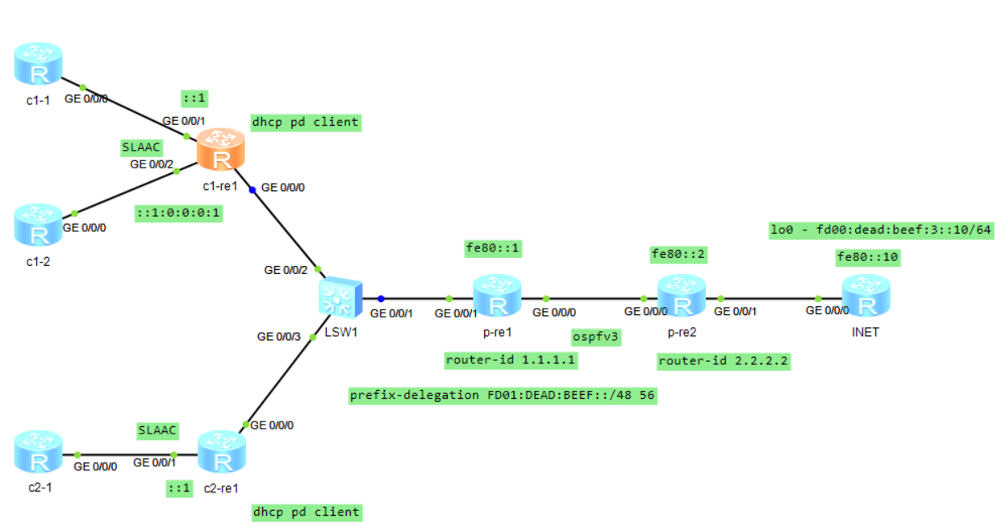

Конфигурации
[V200R003C00]
#
sysname INET
#
ipv6
#
interface GigabitEthernet0/0/0
ipv6 enable
ipv6 address FE80::10 link-local
#
interface GigabitEthernet0/0/1
#
interface GigabitEthernet0/0/2
#
interface NULL0
#
interface LoopBack0
ipv6 enable
ipv6 address FD00:DEAD:BEEF:3::10/64
#
ipv6 route-static :: 0 GigabitEthernet0/0/0 FE80::2
#
return

[V200R003C00]
#
sysname p-re2
#
ipv6
#
ospfv3 1
router-id 2.2.2.2
silent-interface GigabitEthernet0/0/1
import-route static
#
interface GigabitEthernet0/0/0
ipv6 enable
ipv6 address FE80::2 link-local
ospfv3 1 area 0.0.0.0
#
interface GigabitEthernet0/0/1
ipv6 enable
ipv6 address FE80::2 link-local
#
interface GigabitEthernet0/0/2
#
interface NULL0
#
ipv6 route-static FD00:DEAD:BEEF:3:: 64 GigabitEthernet0/0/1
ipv6 route-static FD00:DEAD:BEEF:3:: 64 GigabitEthernet0/0/1 FE80::10
#
return

[V200R003C00]
#
sysname p-re1
#
ipv6
#
dhcp enable
#
dhcpv6 pool clients
prefix-delegation FD01:DEAD:BEEF::/48 56
#
ospfv3 1
router-id 1.1.1.1
silent-interface GigabitEthernet0/0/1
import-route static
#
interface GigabitEthernet0/0/0
ipv6 enable
ipv6 address FE80::1 link-local
ospfv3 1 area 0.0.0.0
#
interface GigabitEthernet0/0/1
ipv6 enable
ipv6 address FE80::1 link-local
undo ipv6 nd ra halt
dhcpv6 server clients
#
interface GigabitEthernet0/0/2
#
interface NULL0
#
ipv6 route-static FD01:DEAD:BEEF:: 56 GigabitEthernet0/0/1 FE80::2E0:FCFF:FEEF:1
8DC
ipv6 route-static FD01:DEAD:BEEF:100:: 56 GigabitEthernet0/0/1 FE80::2E0:FCFF:FE
65:AF8
#
return

[V200R003C00]
#
sysname c1-re1
#
ipv6
#
dhcp enable
#
interface GigabitEthernet0/0/0
ipv6 enable
ipv6 address auto global default
dhcpv6 client pd c1
#
interface GigabitEthernet0/0/1
ipv6 enable
ipv6 address c1 ::1/64
ipv6 address auto link-local
undo ipv6 nd ra halt
#
interface GigabitEthernet0/0/2
ipv6 enable
ipv6 address c1 ::1:0:0:0:1/64
ipv6 address auto link-local
undo ipv6 nd ra halt
#
interface NULL0
#
return

[V200R003C00]
#
sysname c2-re1
#
ipv6
#
set cpu-usage threshold 80 restore 75
#
dhcp enable
#
interface GigabitEthernet0/0/0
ipv6 enable
ipv6 address auto global default
dhcpv6 client pd c2
#
interface GigabitEthernet0/0/1
ipv6 enable
ipv6 address c2 ::1/64
ipv6 address auto link-local
undo ipv6 nd ra halt
#
interface GigabitEthernet0/0/2
#
interface NULL0
#
return

[V200R003C00]
#
sysname c1-1
#
ipv6
#
interface GigabitEthernet0/0/0
ipv6 enable
ipv6 address auto global default
#
interface GigabitEthernet0/0/1
#
interface GigabitEthernet0/0/2
#
interface NULL0
#
return

[V200R003C00]
#
sysname c1-2
#
ipv6
#
interface GigabitEthernet0/0/0
ipv6 enable
ipv6 address auto global default
#
interface GigabitEthernet0/0/1
#
interface GigabitEthernet0/0/2
#
interface NULL0
#
return

[V200R003C00]
#
sysname c2-1
#
ipv6
#
interface GigabitEthernet0/0/0
ipv6 enable
ipv6 address auto global default
#
interface GigabitEthernet0/0/1
#
interface GigabitEthernet0/0/2
#
interface NULL0
#
return

Настраивание и диагностические команды
В данной топологии p-re1 и p-re2 используются как граничные маршрутизаторы провайдера. На них включен ospfv3 с импортом статических маршрутов на обоих.
На p-re1 настроен prefix-delegation FD01:DEAD:BEEF::/48 56. Поскольку по умолчанию маршруты до подсетей клиентов, для которых выдается префикс, не добавляются на данный маршрутизатор, эти маршруты добавлены статически.
На «компьютерах» клиентов получение глобального (ULA) адреса осуществляется через SLAAC.
После добавления статических маршрутов (указано в конфигурациях стоит проверить маршруты и выделенные префиксы на p-re1:
[p-re1]dis dhcpv6 pool clients
DHCPv6 pool: clients
Prefix delegation: FD01:DEAD:BEEF::/48 56
Lifetime valid 172800 seconds, preferred 86400 seconds
2 in use
Information refresh time: 86400
Conflict-address expire-time: 172800
Active pd clients: 2

[p-re1]dis dhcpv6 pool clients allocated prefix
Prefix/length Valid Expires Left

-------------------------------------------------------------------------------
FD01:DEAD:BEEF::/56 172800 2023-12-10 10:43:50 158517

FD01:DEAD:BEEF:100::/56 172800 2023-12-10 10:44:00 158527
-------------------------------------------------------------------------------
Total : 2

Как видно, префикс был выделен для двух клиентов. Таблица маршрутизации на нем следующая:
[p-re1]dis ipv6 routing-table
Routing Table : Public
Destinations : 5 Routes : 5

Destination : ::1 PrefixLength : 128
NextHop : ::1 Preference : 0
Cost : 0 Protocol : Direct
RelayNextHop : :: TunnelID : 0x0
Interface : InLoopBack0 Flags : D

Destination : FD00:DEAD:BEEF:3:: PrefixLength : 64
NextHop : FE80::2 Preference : 150
Cost : 1 Protocol : OSPFv3ASE
RelayNextHop : :: TunnelID : 0x0
Interface : GigabitEthernet0/0/0 Flags : D

Destination : FD01:DEAD:BEEF:: PrefixLength : 56
NextHop : FE80::2E0:FCFF:FEEF:18DC Preference : 60
Cost : 0 Protocol : Static
RelayNextHop : :: TunnelID : 0x0
Interface : GigabitEthernet0/0/1 Flags : D

Destination : FD01:DEAD:BEEF:100:: PrefixLength : 56
NextHop : FE80::2E0:FCFF:FE65:AF8 Preference : 60
Cost : 0 Protocol : Static
RelayNextHop : :: TunnelID : 0x0
Interface : GigabitEthernet0/0/1 Flags : D

Destination : FE80:: PrefixLength : 10
NextHop : :: Preference : 0
Cost : 0 Protocol : Direct
RelayNextHop : :: TunnelID : 0x0
Interface : NULL0 Flags : D

Проверка достучаться до INET с c1-1:
<c1-1>ping ipv6 fd00:dead:beef:3::10
PING fd00:dead:beef:3::10 : 56 data bytes, press CTRL_C to break
Reply from FD00:DEAD:BEEF:3::10
bytes=56 Sequence=1 hop limit=61 time = 310 ms
Reply from FD00:DEAD:BEEF:3::10
bytes=56 Sequence=2 hop limit=61 time = 70 ms
Reply from FD00:DEAD:BEEF:3::10
bytes=56 Sequence=3 hop limit=61 time = 40 ms
Reply from FD00:DEAD:BEEF:3::10
bytes=56 Sequence=4 hop limit=61 time = 50 ms
Reply from FD00:DEAD:BEEF:3::10
bytes=56 Sequence=5 hop limit=61 time = 60 ms

--- fd00:dead:beef:3::10 ping statistics ---
5 packet(s) transmitted
5 packet(s) received
0.00% packet loss
round-trip min/avg/max = 40/106/310 ms

<c1-1>tracert ipv6 fd00:dead:beef:3::10

traceroute to fd00:dead:beef:3::10 30 hops max,60 bytes packet

1 FD01:DEAD:BEEF:100::1 120 ms 60 ms 20 ms

2 * * *

3 * * *

4 FD00:DEAD:BEEF:3::10 190 ms 60 ms 80 ms

На 2 и 3 звездочки, потому что на маршрутизаторах провайдера только link-local адреса.

